High End Assignment - CO1 -
Department | AI&DS
Course Code / Course Name | DSA0602/ Data Handling and Visualization
Assignement | High End Assignment - CO1 -
Name | Addula Yaswanth
Register Number | 192324179
Date | 07 October 2026
Day | Wednesday

Q1. R Code to Visual: Colour scale for data values [10 marks]
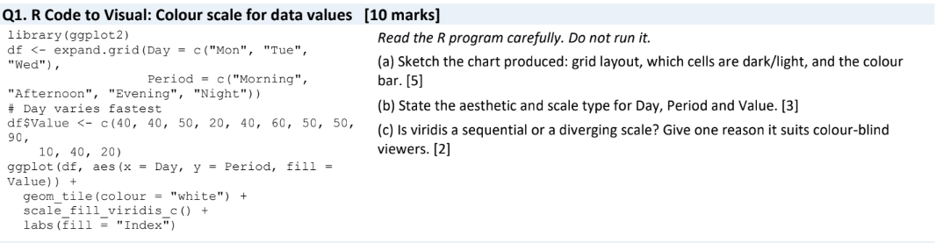
(a) Sketch / interpretation of the chart
The code produces a 4 × 5 heatmap.
- X-axis: Day – Mon, Tue, Wed, Thu, Fri
- Y-axis: Period – Morning, Afternoon, Evening, Night
- Each cell represents the Value.
- Lower values appear light.
- Higher values appear dark.
- geom_tile() creates the rectangular cells.
- scale_fill_viridis_c() provides the colour scale.
The values are arranged with Day varying fastest, as mentioned in the question.
(b) Aesthetic and scale type
Variable | Aesthetic | Scale type
Day | x-position | Discrete
Period | y-position | Discrete
Value | fill/colour | Continuous

(c) Viridis scale
Viridis is a sequential colour scale.
It is suitable for colour-blind viewers because it provides clear differences in brightness and colour, making low and high values easier to distinguish.

Q2. Visual to R Code: Colour as a tool to highlight [10 marks]
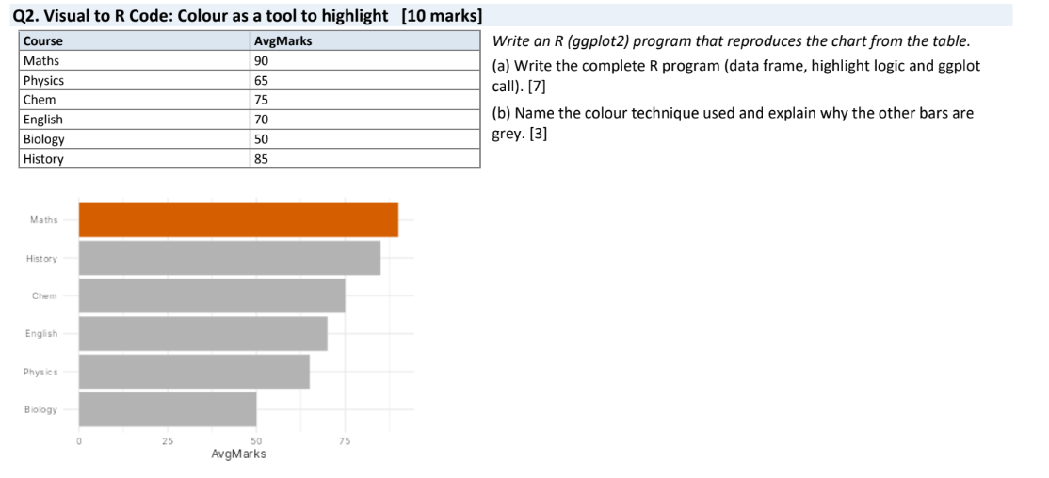
(a) Complete R program
library(ggplot2)

data <- data.frame(
Course = c("Maths", "Physics", "Chem", "English", "Biology", "History"),
AvgMarks = c(90, 65, 75, 70, 50, 85)
)

# Highlight the highest mark
data$Colour <- ifelse(data$AvgMarks == max(data$AvgMarks),
"orange", "grey")

ggplot(data, aes(x = reorder(Course, AvgMarks),
y = AvgMarks,
fill = Colour)) +
geom_col() +
scale_fill_identity() +
coord_flip() +
labs(x = "Course",
y = "Average Marks",
title = "Average Marks by Course") +
theme_minimal() +
guides(fill = "none")

Output:
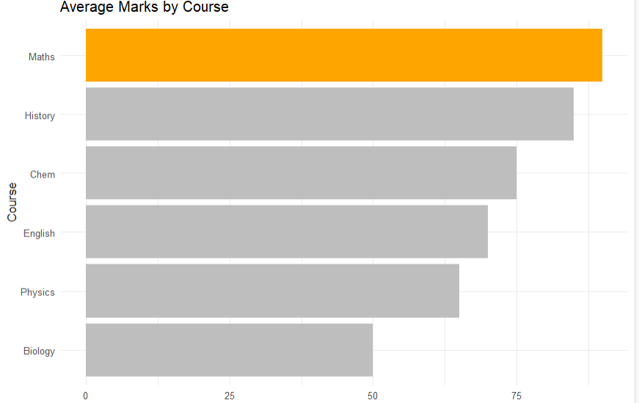
(b) Colour technique
The technique used is conditional highlighting using colour.
- Maths has the highest mark, so it is highlighted in orange.
- All other bars are shown in grey.
- This makes the important value immediately noticeable.
- Grey bars provide a neutral background so the highlighted bar gets attention.

Q3. Visual to Table: Reading a colour scale [10 marks]
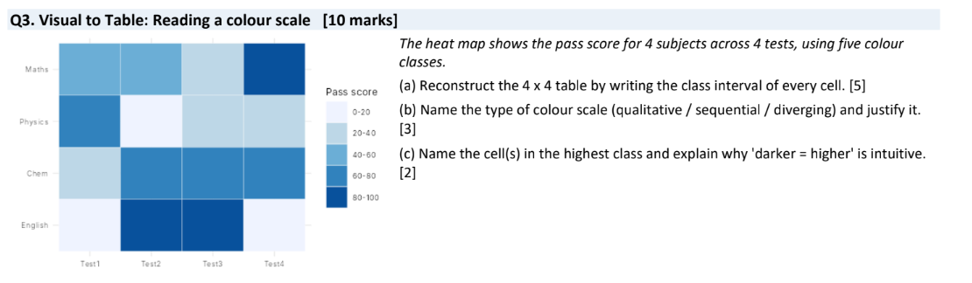
(a) Reconstructed 4 × 4 table
The colour scale has these classes:
- 0–20
- 20–40
- 40–60
- 60–80
- 80–100
Subject | Test 1 | Test 2 | Test 3 | Test 4
Maths | 40–60 | 40–60 | 20–40 | 80–100
Physics | 60–80 | 0–20 | 20–40 | 20–40
Chem | 20–40 | 60–80 | 60–80 | 60–80
English | 0–20 | 80–100 | 80–100 | 0–20

(b) Type of colour scale
The heatmap uses a sequential colour scale.
It is sequential because the colours progress from light to dark as the pass score increases.
(c) Highest class cells
The cells in the 80–100 class are:
- Maths – Test 4
- English – Test 2
- English – Test 3
They are darkest because darker colour represents a higher pass score.

Q4. Table to Visual: Cartesian versus polar coordinates [10 marks]
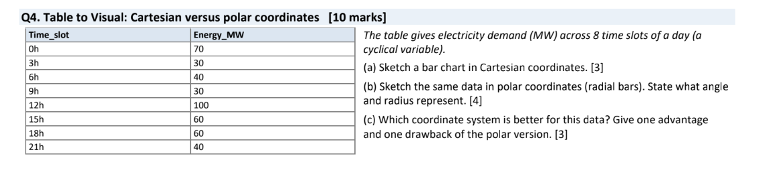
Given data:
(a) Cartesian bar chart
Draw a normal bar chart:
- X-axis: Time
- Y-axis: Energy demand (MW)
- Bar heights: 70, 30, 40, 30, 100, 60, 60, 40
- The highest bar is at 12h = 100 MW.
- The lowest bars are at 3h and 9h = 30 MW.
Time | Energy_MW
0h | 70
3h | 30
6h | 40
9h | 30
12h | 100
15h | 60
18h | 60
21h | 40

(b) Polar bar chart
In a polar chart:
- Angle represents the time of day.
- Radius/bar length represents energy demand in MW.
- There are 8 equally spaced bars around the circle.
- The 12h bar is the longest because demand is 100 MW.
- The 3h and 9h bars are the shortest because demand is 30 MW.
(c) Best coordinate system
Polar coordinates are better for this data because the data represents a cyclic 24-hour time pattern.
Advantage:
It clearly shows the daily cycle and makes it easy to see how energy demand changes around the day.
One drawback:
Comparing exact bar heights is harder in a polar chart than in a Cartesian bar chart.

Q5. Design Decision: Choosing Aesthetics and a Colour Palette [10 marks]
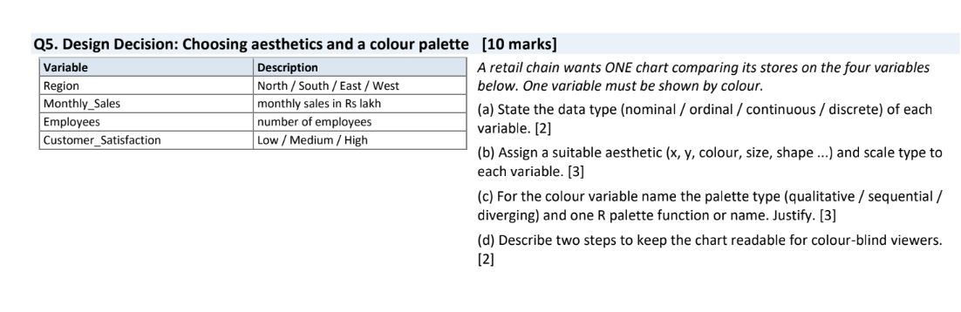

(a) State the data type (nominal / ordinal / continuous / discrete) of each
variable.

Variable | Data Type
Region | Nominal
Monthly_Sales | Continuous
Employees | Discrete
Customer_Satisfaction | Ordinal

(b) Assign a suitable aesthetic (x, y, colour, size, shape ...) and scale type to
each variable.
Variable | Aesthetic | Scale Type
Region | X-axis | Discrete
Monthly_Sales | Y-axis | Continuous
Employees | Size | Continuous
Customer_Satisfaction | Colour | Discrete / Ordinal

Suitable chart: Scatter plot with:
- X = Region
- Y = Monthly Sales
- Size = Employees
- Colour = Customer Satisfaction
(c) For the colour variable name the palette type (qualitative / sequential / diverging) and one R palette function or name. Justify.
Palette type: Sequential
R palette: viridis
Customer satisfaction has an order: Low → Medium → High. Therefore, a sequential palette is suitable because the colours can progress from lighter to darker according to satisfaction level.
Example:
scale_color_viridis_d()

(d) Describe two steps to keep the chart readable for colour-blind viewers.
- Use a colour-blind-friendly palette such as Viridis.
- Do not depend only on colour; use different shapes, labels, or legends to distinguish categories clearly.

